TRAINING AND VALIDATION LOSS :
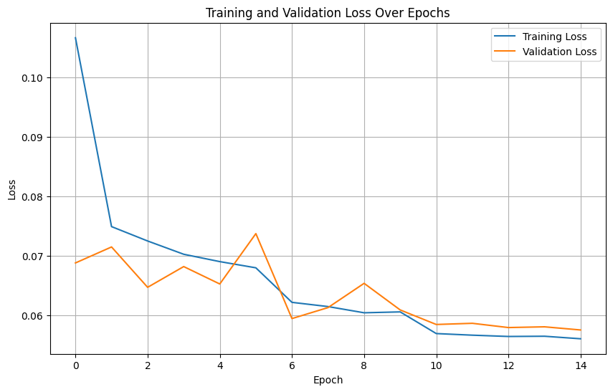
PREDICTED VS ACTUAL TEMPERATURE
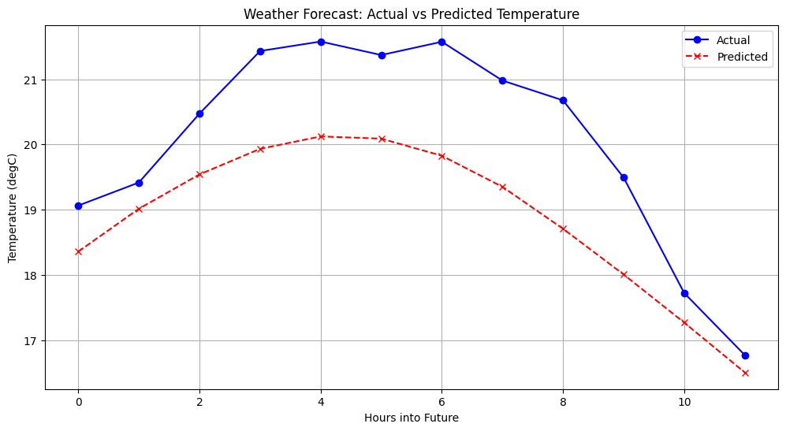

Metrics for Hour 1 into the future:
MAE: 0.5894
MSE: 0.6271
RMSE: 0.7919

Metrics for Hour 2 into the future:
MAE: 0.8377
MSE: 1.2830
RMSE: 1.1327

Metrics for Hour 3 into the future:
MAE: 1.0676
MSE: 2.0507
RMSE: 1.4320

Metrics for Hour 4 into the future:
MAE: 1.2608
MSE: 2.7978
RMSE: 1.6727

Metrics for Hour 5 into the future:
MAE: 1.4180
MSE: 3.4801
RMSE: 1.8655

Metrics for Hour 6 into the future:
MAE: 1.5464
MSE: 4.0983
RMSE: 2.0244

Metrics for Hour 7 into the future:
MAE: 1.6527
MSE: 4.6455
RMSE: 2.1553

Metrics for Hour 8 into the future:
MAE: 1.7448
MSE: 5.1382
RMSE: 2.2668

Metrics for Hour 9 into the future:
MAE: 1.8271
MSE: 5.5896
RMSE: 2.3642

Metrics for Hour 10 into the future:
MAE: 1.9015
MSE: 6.0123
RMSE: 2.4520

Metrics for Hour 11 into the future:
MAE: 1.9618
MSE: 6.3791
RMSE: 2.5257

Metrics for Hour 12 into the future:
MAE: 2.0109
MSE: 6.6976
RMSE: 2.5880

--- Overall Metrics (across all predicted hours) ---
Overall MAE: 1.4849
Overall MSE: 4.0666
Overall RMSE: 2.0166

--- Model Weights Analysis ---
Layer: lstm1.cell.W | Size: torch.Size([640, 14]) | Mean: -0.0006 | Std: 0.0433
Layer: lstm1.cell.U | Size: torch.Size([640, 160]) | Mean: 0.0002 | Std: 0.0145
Layer: lstm1.cell.b | Size: torch.Size([640]) | Mean: 0.0283 | Std: 0.0674
Layer: lstm2.cell.W | Size: torch.Size([640, 160]) | Mean: 0.0003 | Std: 0.0144
Layer: lstm2.cell.U | Size: torch.Size([640, 160]) | Mean: -0.0001 | Std: 0.0136
Layer: lstm2.cell.b | Size: torch.Size([640]) | Mean: 0.0263 | Std: 0.0611
Layer: lstm3.cell.W | Size: torch.Size([640, 160]) | Mean: -0.0001 | Std: 0.0134
Layer: lstm3.cell.U | Size: torch.Size([640, 160]) | Mean: 0.0002 | Std: 0.0093
Layer: lstm3.cell.b | Size: torch.Size([640]) | Mean: 0.0237 | Std: 0.0357
Layer: fc.weight | Size: torch.Size([12, 160]) | Mean: -0.0118 | Std: 0.0888
Layer: fc.bias | Size: torch.Size([12]) | Mean: -0.0290 | Std: 0.0077

